**PF ASSIGNMENT - 07**

**QUESTION#1**

Write a program which will find the factorial of a given number. Exit the program if the input number is negative.

Example of Factorial: Input number = 5 Factorial is=5*4*3*2*1

**Note: Justify your choice of loop answering two important points: why your choice is optimal? Why other looping structure would not be suitable?**

Answer:

This task can be performed using FOR & WHILE LOOP, but DO-WHILE cannot be use, as do-while at least run 1 time even the condition is wrong.

**(I have used FOR LOOP in this case because I know the number of iterations it is going to do.)**

**WHILE-LOOP** is best when we don’t know the number of iteration we have to do.

Source Code:

Output:

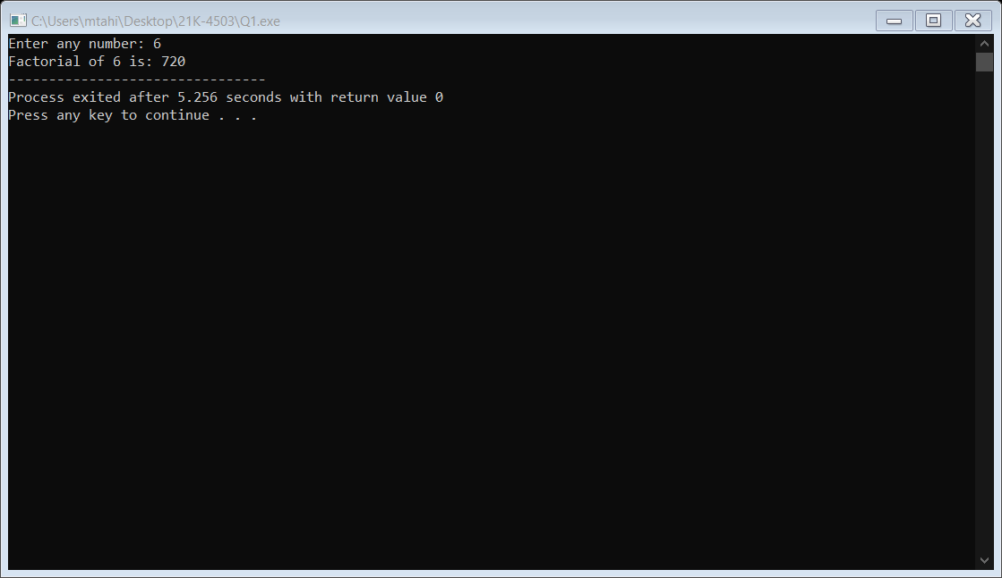

**QUESTION#2**

Ask the user to input an integer (N > 10) then input the N numbers from user only allowing positive integers. Calculate the average value of the inputs, count the odd, even and the numbers which are factor of 3.

Source Code:

Output:

**QUESTION#3**

Write a program which will input a 5-digit number. If the sum of digits is even, find whether the input number is a prime or not. If the sum of digits is odd find, whether the number is palindrome or not?

Example of prime number: A number which is only divisible by itself and 1 i.e., 7, 11, and13.

Example of a Palindrome: A number whose reverse order is the same as the original number i.e., 11211, 44344.

Source Code:

Output:

**QUESTION#4**

Write a program which will generate the Fibonacci series up to 500. Also find the sum of the generated Fibonacci numbers divisible by 2, 3 and 5 only.

Source Code:

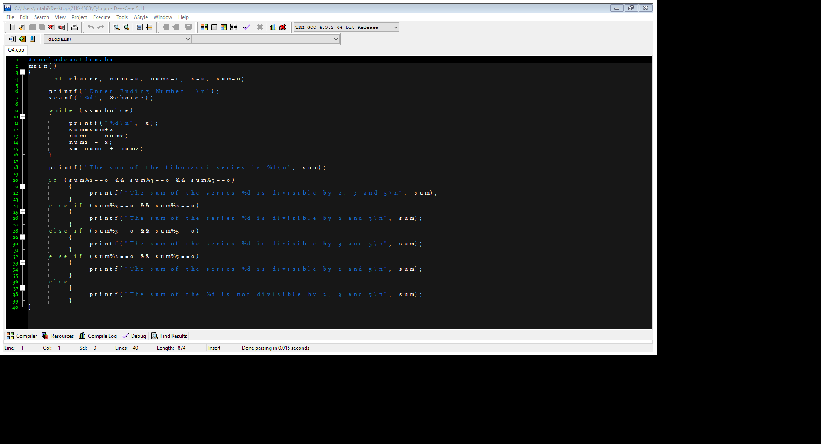

Output:

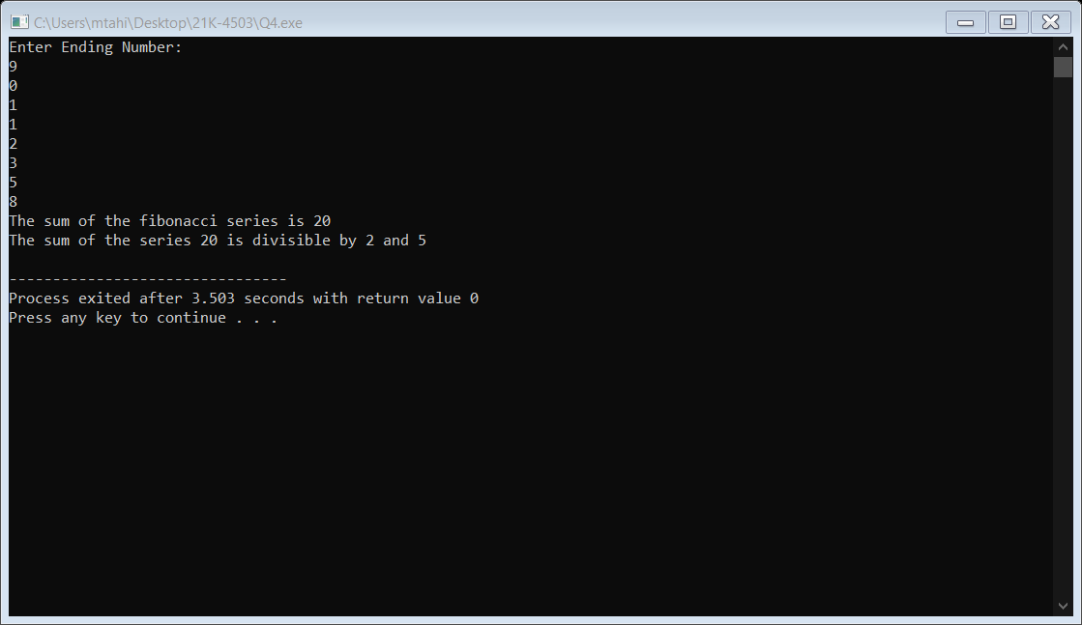

**QUESTION#5**

Write a program which inputs the 25 student’s marks (out of 100) and counts the number of failed and passed students. How many students are excellent and how many are above average.

Note: Passing marks = 50, A+ = 90 – 100 (Outstanding), A = 86 - 89 (Excellent), B+ = 75 – 85 (Good), B- = 70 – 74 (Average), C+ = 66 – 69 (Below Average), C = 62 – 65 (Adequate), C- = 58 – 61 (Pass), D+ 54 – 57 (Pass), D = 50 – 53 (Pass).

Source Code:

Output:

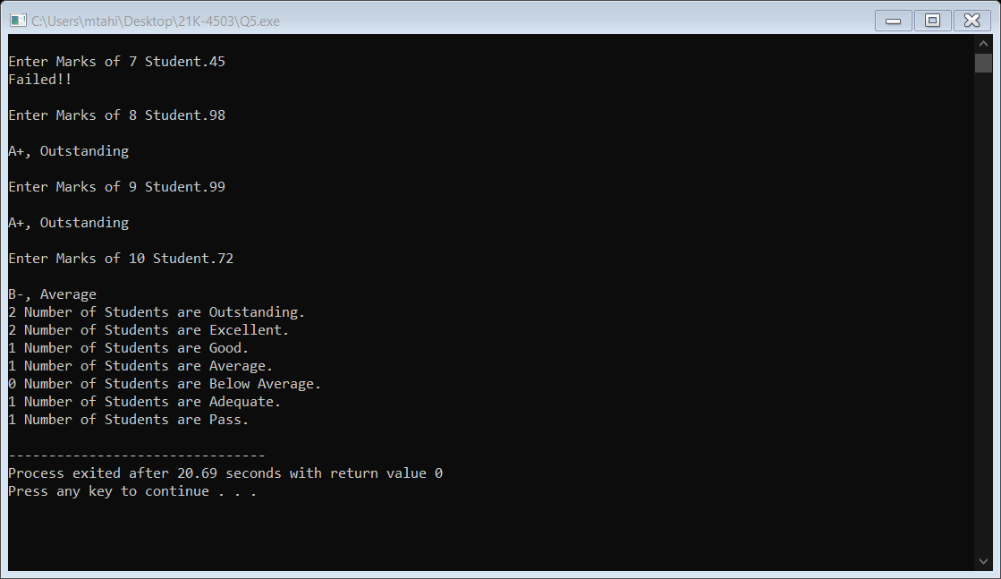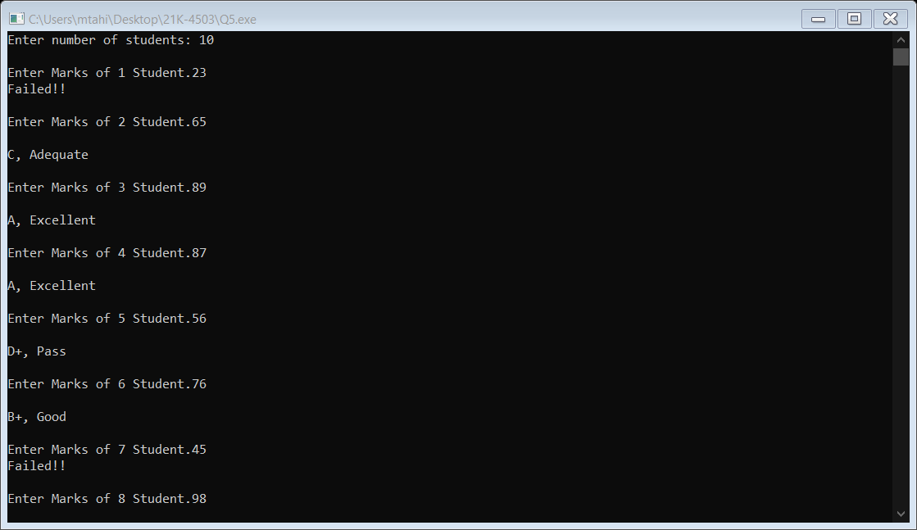

**QUESTION#6**

write a program which will be used to take the entry test for university students. The program must have following features.

1. For correct answer, students get 4 marks.
2. For wrong answer, student lose 1 mark.
3. If the student answers first four questions wrong exit the program with a message “Sorry,
4. you did not qualify for the admission.”
5. If students score 20 marks, program should display “Congratulations, you have qualified for
6. the admission “and exit.
7. There will be only 4 options for each question

Source Code:

Output:

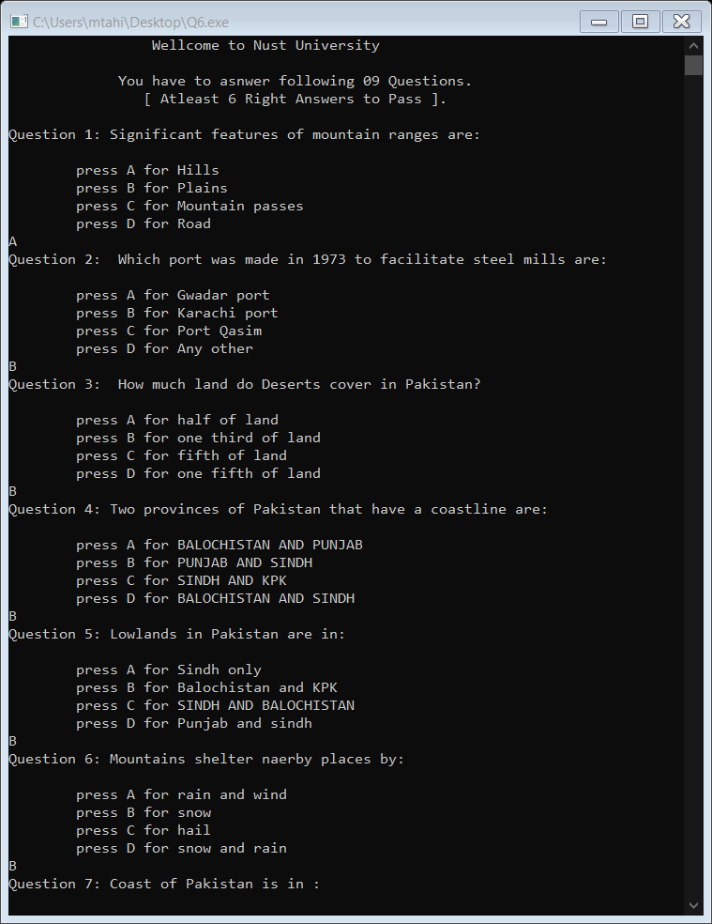

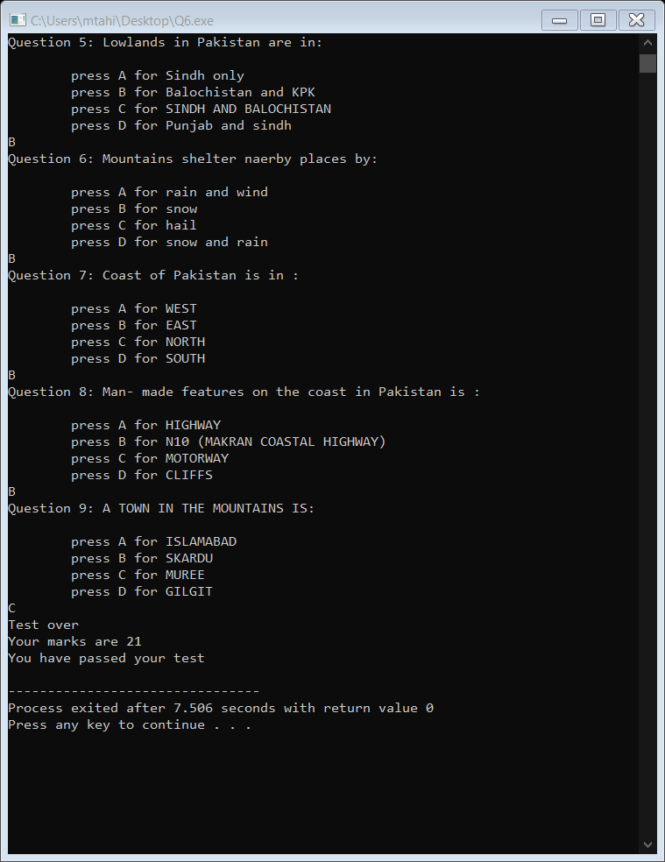

**QUESTION#7**

Develop a user-registration system have the following options.

1. Ask the user for a username (5 alphabets).
2. Password should be 6 characters long with at least 1 numeric, 1 capital and 1 small letter.
3. Display a “Account Created Successfully”.
4. Login the user with correct username and password.
5. Display “Welcome username, you are now logged in”.

Source Code:

Output:

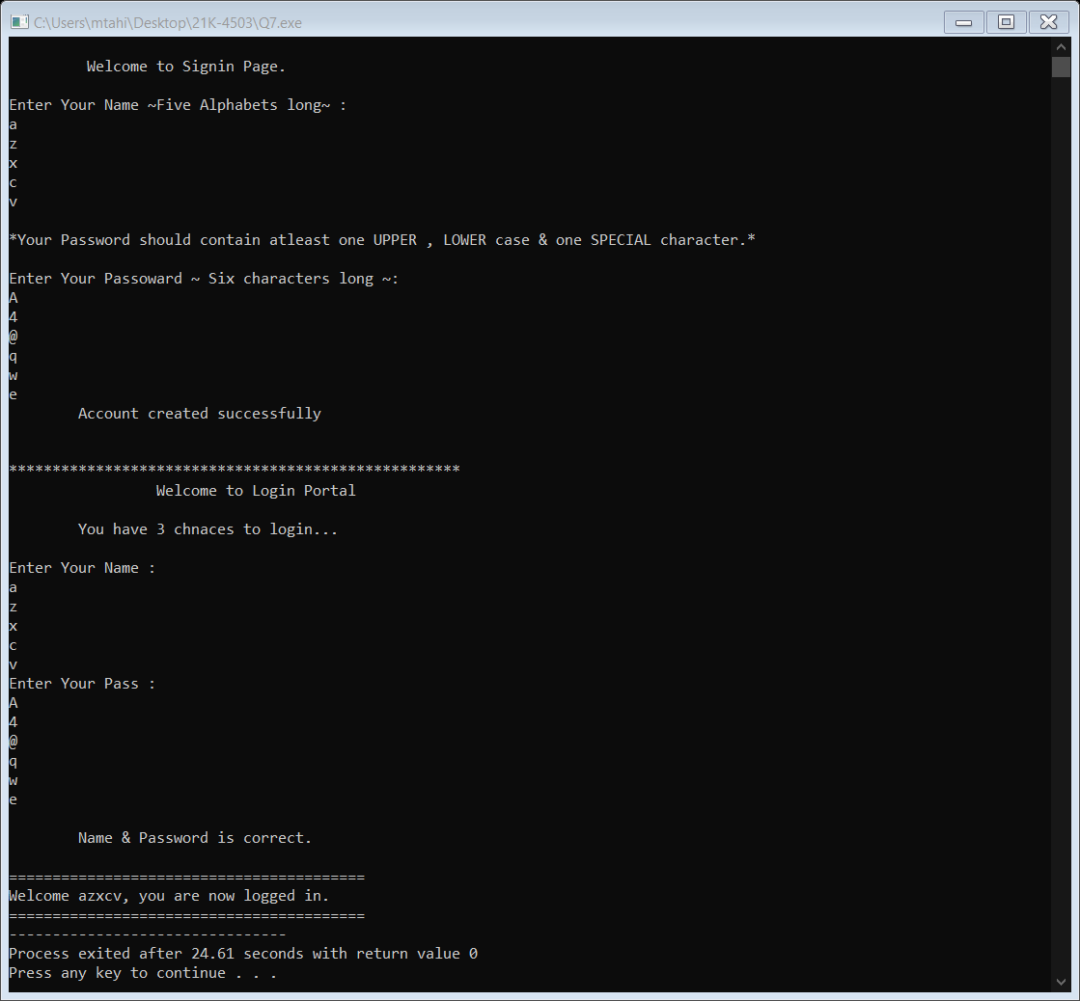

**QUESTION#8**

At a popular car showroom, a salesperson is rewarded 2% of the sales s/he do. If a salesperson makes the sales worth of 10 million their reward is increased to 3.5%. Calculate the net salary of all the salesperson at the showroom by asking their base salary and monthly sales. No salesperson has base salary less than RS. 60,000 exit the program if base salary is less than RS. 60,000.

Source Code:

Output:

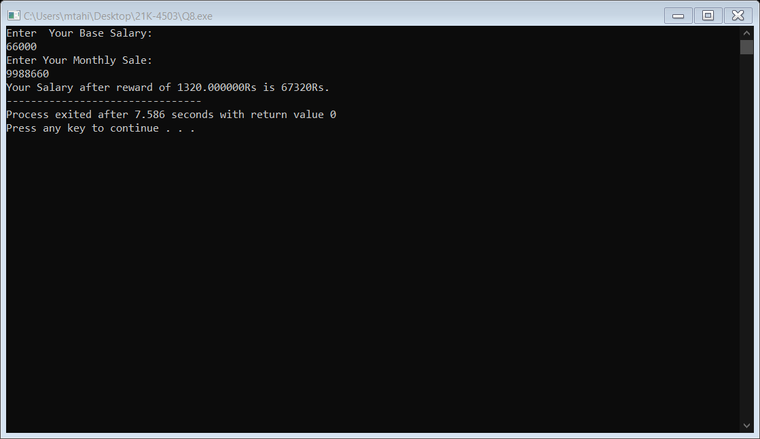

**QUESTION# [ EXTRA]**

you are asked to generate an electricity bill. write a program to calculate the total electricity bill according to the given condition:  
For the first 50 units Rs. 0.50/unit  
For the next 100 units Rs. 0.75/unit  
For the next 100 units Rs. 1.20/unit  
For units above 250 Rs. 1.50/unit  
An additional surcharge of 20% is added to the bill.

Source Code:

Output:

